Student’s name | …………………………………………………….…… | Grade | 4
Subject | Computer | Week No. | 8
Lesson Title | Scratch Extensions | Unit
Worksheet No. ( 8 ) (Answer)

write the correct name of each part.



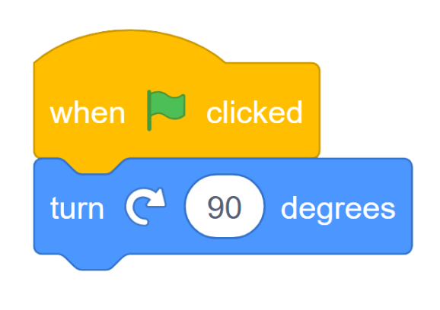
broadcast
Code
Default sprite
Printer
broadcast
Printer
Code
RAM
Default sprite
Good Luck

